**NEW at XYZ Wellness - Celluma (LED) Light Therapy**

**ACNE • ANTI-AGING • PAIN • HAIR RESTORATION • WOUND HEALING\***

**What is Light Therapy?**

Light Emitting Diode (LED) phototherapy is the application of light energy to tissue to obtain therapeutic benefits.  The energy is used to improve cellular performance.  Phototherapy is known for its healing and anti-inflammatory properties and has a variety of applications across many medical fields.  Research has shown that phototherapy can: increase circulation, accelerate tissue repair, decrease wrinkles, decrease inflammation, improve skin tone and wrinkles, texture and clarity, ease muscle and joint pain, stiffness, spasm and arthritis and kill acne bacteria, and much more.

**How Does Light Energy work?**

Specific wavelengths of light energy, when properly absorbed, up-regulates compromised cells. The light (photons) energy is absorbed by photoacceptors in the mitochondria and used to create adenosine triphosphate (ATP). The ATP produced then stimulates various metabolic processes which can result in the repair and regeneration of cell and tissue components. In an article, “Therapeutic Light” - by Chukuku S. Enwemeka, PT, PhD, FACSM, he wrote “other reported mechanisms of light-induced beneficial effects include modulation of prostaglandin levels, alteration of somatosensory evoked potential and nerve conduction velocity, and hyperemia of treated tissues. The resultant clinical benefits include pain relief in conditions such as carpal tunnel syndrome, bursitis, tendonitis, ankle sprain, and temporomandibular joint dysfunction, shoulder and neck pain, arthritis, and post-herpetic neuralgia, as well as tissue repair in cases of diabetic ulcer, venous ulcer, mouth ulcer, fractures, tendon rupture, ligamentous, tear, torn cartilage, and nerve injury.”

**What is Celluma?**

Celluma is unique and quite unlike any other low-level light therapy device available today. Based on NASA research, Cellumadelivers blue, red and near-infrared light energy simultaneously to safely treat a wide variety of conditions. Each wavelength is absorbed by different molecules that act as a signaling mechanism for different cellular processes. For example, some reduce inflammation and some kill bacteria, while others enhance localized circulation.

**Ask Us How Celluma Can Benefit You & Your Family**

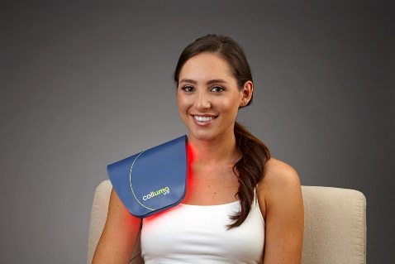 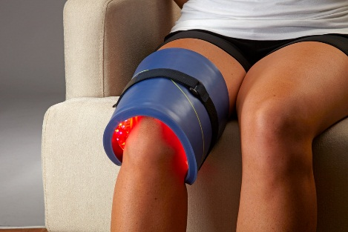 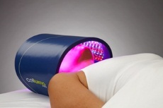

**Award Winning ● FDA Cleared ● Medical CE Mark**

**\*Celluma is not FDA-cleared for wound healing**